- Hyper automation
Introduction:
It is defined by Gartner ,hyper automation “deals with the application of all advanced technologies ,including artificial intelligence (AI) and machine learning (ML).

This was a introduction on my topic given by respected Mr. Praveen Joshi and it's an honour for me to work on this project.

IT Project :
Made by: Ayush Bhatia
Class: 9th ‘D'
Submitted to: Mr. Praveen Joshi
School: Evergreen Sr. Sec. School
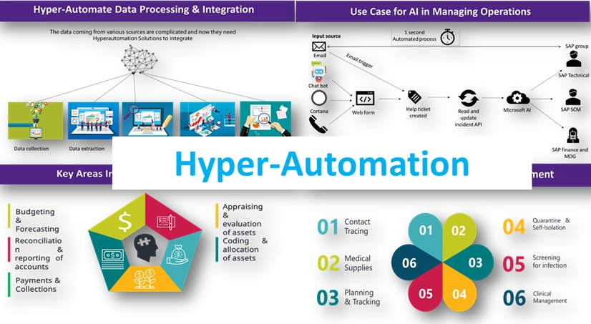
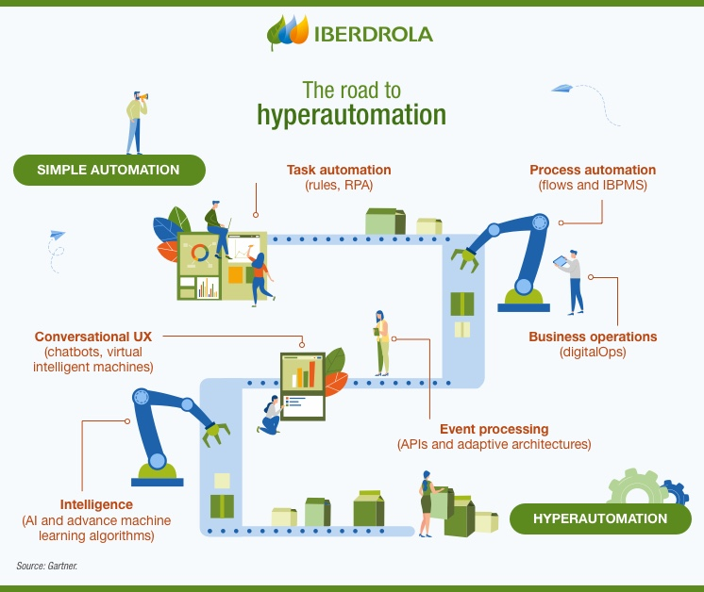
  - What is Hyper-Automation ?

In simple – Terms, hyper-automation refers to the misphere of automation technologies that exist to augment and expand human capabilities.
It enables machines to automate the further implementation of additional automation without the input of human assistance.

- we are talking about an array of technology terms, let me tell another important hyper- automation to take place,
It is namely:-

  - Robotic process Automation:

- robotic process automation is a robot dead can perform low level And repeated tasks with RPA you can also programme a robot or system to produce outputs.

- The next easy machine learning:- as a branch of artificial intelligence, machine learning refers to the system that can be used to data for identifying patterns and learn from them.

- The system's algorithms is first trained using training data and then creates a model for usage.
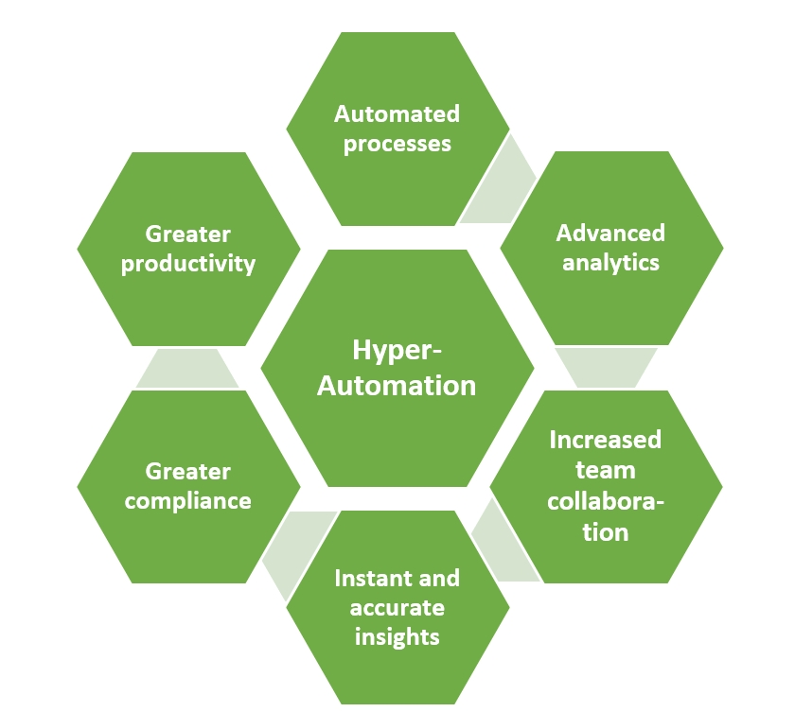
  - Components of Hyper-Automation:

- components of Hyper Automation
  - Robotic Process Automation.
  - Intelligent business process Management.
  - Artificial Intelligence.
  - Advanced Analytics.

  - What is IBPMs?

IBPM stand for intelligent business process management ,it takes an already great BPM tool and enriches it with additional intelligence, including feature like cloud computing, event processing, real- time decision-making ,And systems crosslinking.

  - A Little bit About BI :-

If we are talking about my IBPM then taking BI concept is also important BI is business intelligence and it's a type of software that can harness the power of data within an organisation. It Millie help companies to make strategic productivity improve revenue, and enhance growth .
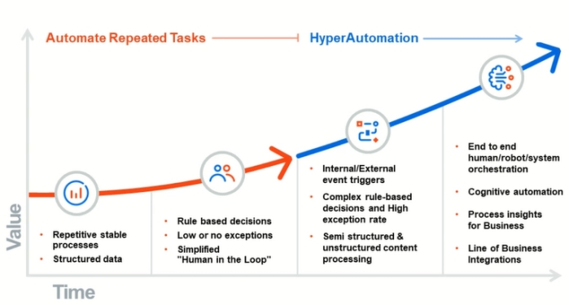
  - Advanced Analytics:-

- Advanced analytics employees predictive modelling, statistical methods , machine learning algorithm. Basically, It is a data analysis methodology and uses this tactical method to analysis business information from a variety of data sources.

- (Digitization) + (Connecting) + (Artificial Intelligence) = Hyper-Automation.

- Hyper-Automation is business-driven, disciplined approach that organisation used to rapidly identify, let and automate as many business and IT process as possible.

- hyper automation involves the Orchestrated use of multiple technologies, tools or platforms, including: Artificial Intelligence (AI) .

  - Conclusion:-

Example of Hyper-Automation:-

- Understanding documents using OCR (Optical Character Recognition)

- Understanding emails using NLP (Natural Language Processing) Forecaste stock and Automate Restocking.

- Enhancing automation flows using AI/ML (Artificial Intelligence/ Machine Learning).

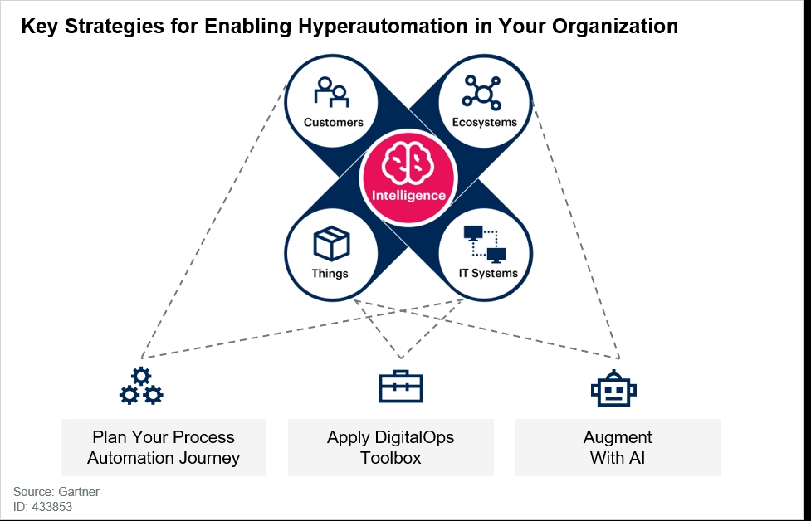

  - Summary:-

Hyperautomation implies a studied approach to automation. A hyperautomation practice involves identifying what work to automate, choosing the appropriate automation tools, driving agility through the reuse of the automated processes, and extending their capabilities using various flavors of AI and machine learning.

*********************************THANK YOU ,THE END*******************

References

- Jing, L., Ming, L., Bin, Y., Wenlong, L., A Novel Energy Efficient MAC Protocol for Wireless Body Area Network. China communication, Feb. 2015.
- Negra, R., Jemili, I., Belghith, A.: Wireless Body Area Networks: Applications and Technologies. Procedia Computer Science 83, 1274 – 1281 ( 2016 )
- Yuce, M.R.: Implementation of wireless body area networks for healthcare systems. In: Sensors and Actuators A: Physical, Vol 162, Issue 1, Pages 116-129. Elsevier B.V (2010)
- Dabhi, K., Mahet, A.: Internet of Nano Things-The Next Big Thing. In: International Journal of Engineering Science and Computing, vol 7 Issue No.4 (2017)
- Negra, R., Jemili, I., Belghith, A.: Wireless Body Area Networks: Applications and Technologies. Procedia Computer Science 83, 1274 – 1281 ( 2016 )
- Yuan, X., Li, C., Ye, Q., Zhan, K., Cheng, N., Zhan, N., Shen, X.: Performance Analysis of IEEE 802.15.6-Based Coexisting Mobile WBANs with Prioritized Trafﬁc and Dynamic Interference. In: IEEE Transactions on Wireless Communications (Volume: 17, Issue: 8, Aug. 2018)
- Adhikary S., Chattopadhyay S., Choudhury S.: A Novel Bio-inspired Algorithm for Increasing Throughput in Wireless Body Area Network (WBAN) by Mitigating Inter-WBAN Interference. In: Chaki R., Cortesi A., Saeed K., Chaki N. (eds) Advanced Computing and Systems for Security. Advances in Intelligent Systems and Computing, vol 667. Springer, Singapore (2018)
- Peng, H., Tian, Y., Kurths, J., Li, L., Yang, Y., Wang, D.: Secure and energy-efﬁcient data transmission system based on chaotic compressive sensing in body-to-body networks. IEEE Trans. Biomed. Circ. Syst. 11(3), 558–573 (2017)
- Samanta, A., Misra, S.: Energy-efﬁcient and distributed network management cost minimization in opportunistic wireless body area networks. IEEE Trans. Mobile Comput. 17, 376–389 (2017)
- Ahmad, S.S., Razzaque, M.A., Inmaculada T.R., Hussain, N.: IEEE 802.15.6 Standard in Wireless Body Area Networks From a Healthcare Point of View. The 22nd Asia-Pacific Conference on Communications (APCC2016)
- Yi, C., Wang, L., Li, Y.: Energy efﬁcient transmission approach for WBAN based on threshold distance. IEEE Sensors J. 15(9), 5133–5141 (2015)
- Misra, S., Moulik, S., Chao, H.-C.: A cooperative bargaining solution for priority-based data-rate tuning in a wireless body area network. IEEE Trans. Wirel. Commun. 14(5), 2769–2777 (2015)
- Walsh, M.J., Hayes, M.J.: Throughput rate control for an 802.15.4 wireless body area network using static and low order anti-windup techniques. In: Proc. Mediterranean Conf. Control Autom, pp.1–6 (2007)
- Eberhart, R., Kennedy, J.: A New Optimizer Using Particle Swarm Theory. Sixth International Symposium on Micro Machine and Human Science, 0-7803-2676-8/95
- Kalaiselvi, K., Suresh, G.R. & Ravi, V.: Genetic algorithm based sensor node classiﬁcations in wireless body area networks (WBAN). Cluster Comput (2018)
- Nadeem, Q., Javaid, N., Mohammad, S.N., Khan, M.Y., Gull, M.: SIMPLE: Stable Increased-throughput Multi-hop Protocol for Link Efﬁciency in Wireless Body Area Networks. 26, Jul. 2013.

